‘Dabba On Wheels’

FINAL PROJECT REPORT

|  |  |  |  |
| --- | --- | --- | --- |
| Team Number 02 | | | |
| Member | Chirag Prashanth | Jaswanth Marri | Manish Choudhary |
| NU ID | 002294498 | 002787572 | 002642438 |
| NU Email | [prashanth.ch@northeastern.edu](mailto:prashanth.ch@northeastern.edu) | [marri.j@northeastern.edu](mailto:marri.j@northeastern.edu) | [choudhary.man@northeastern.edu](mailto:choudhary.man@northeastern.edu) |

*BUSINESS REPORTS-*

1) This report shows us the revenue generated by the customers in order of highest contribution to the lowest. It takes data from customer, subscription and payment table.

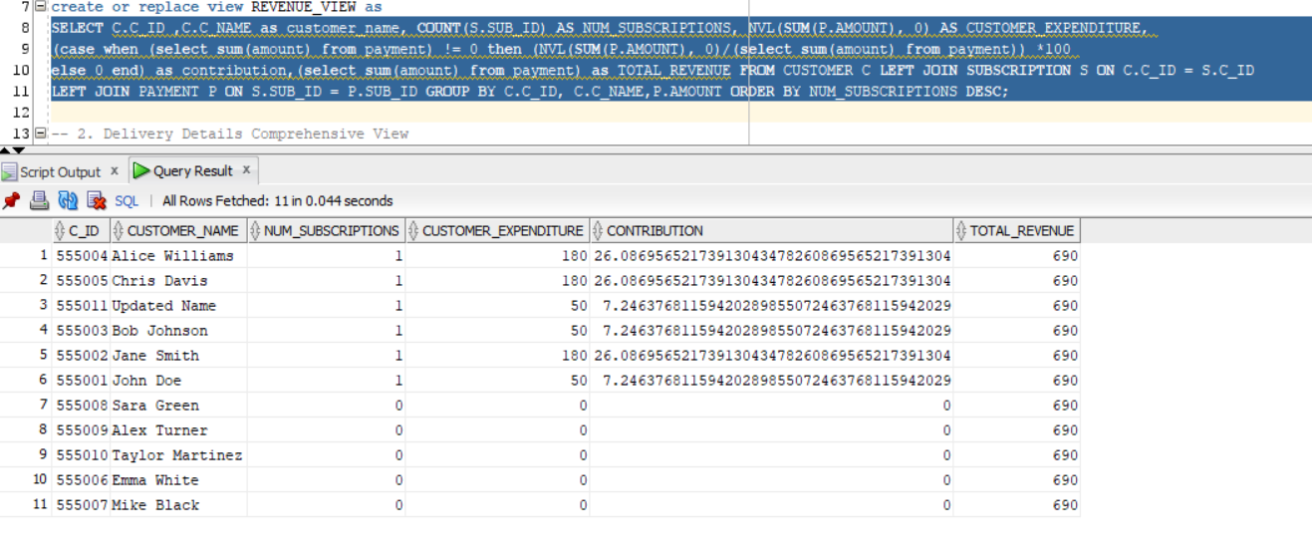

2) This report provides the delivery details of the customer’s order. It takes information from the location, booking, meal, delivery partner, and customer tables

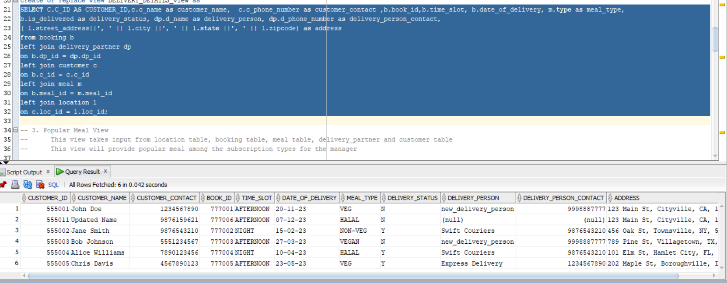

3) This report gives us the popular meal choice of the customers based on their subscription model (Monthly or Weekly). Information is taken from the location, meal, delivery partner and customer tables

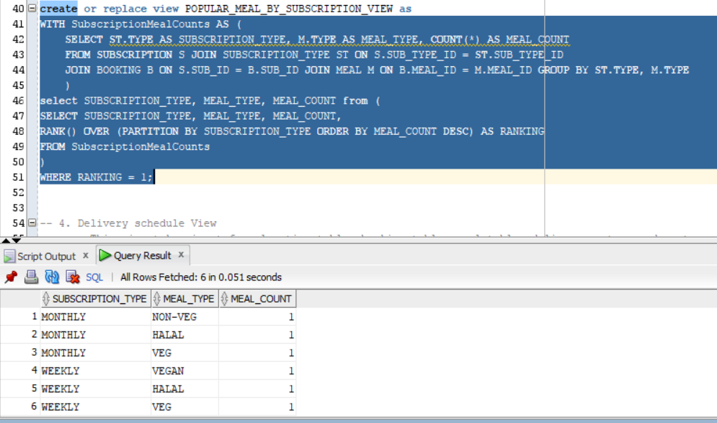

4) This report gives us the delivery schedule details which include delivery person details, delivery date, time slot, delivery status, customer name and delivery address.

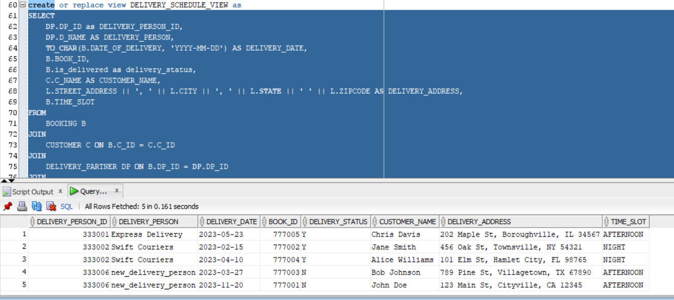

5) This report gives us the meal type preference of the customers based on the season in which they place their orders. The seasons considered are Spring, Summer, Fall and Winter.

